1. **Experiment number1- Based pc communication**

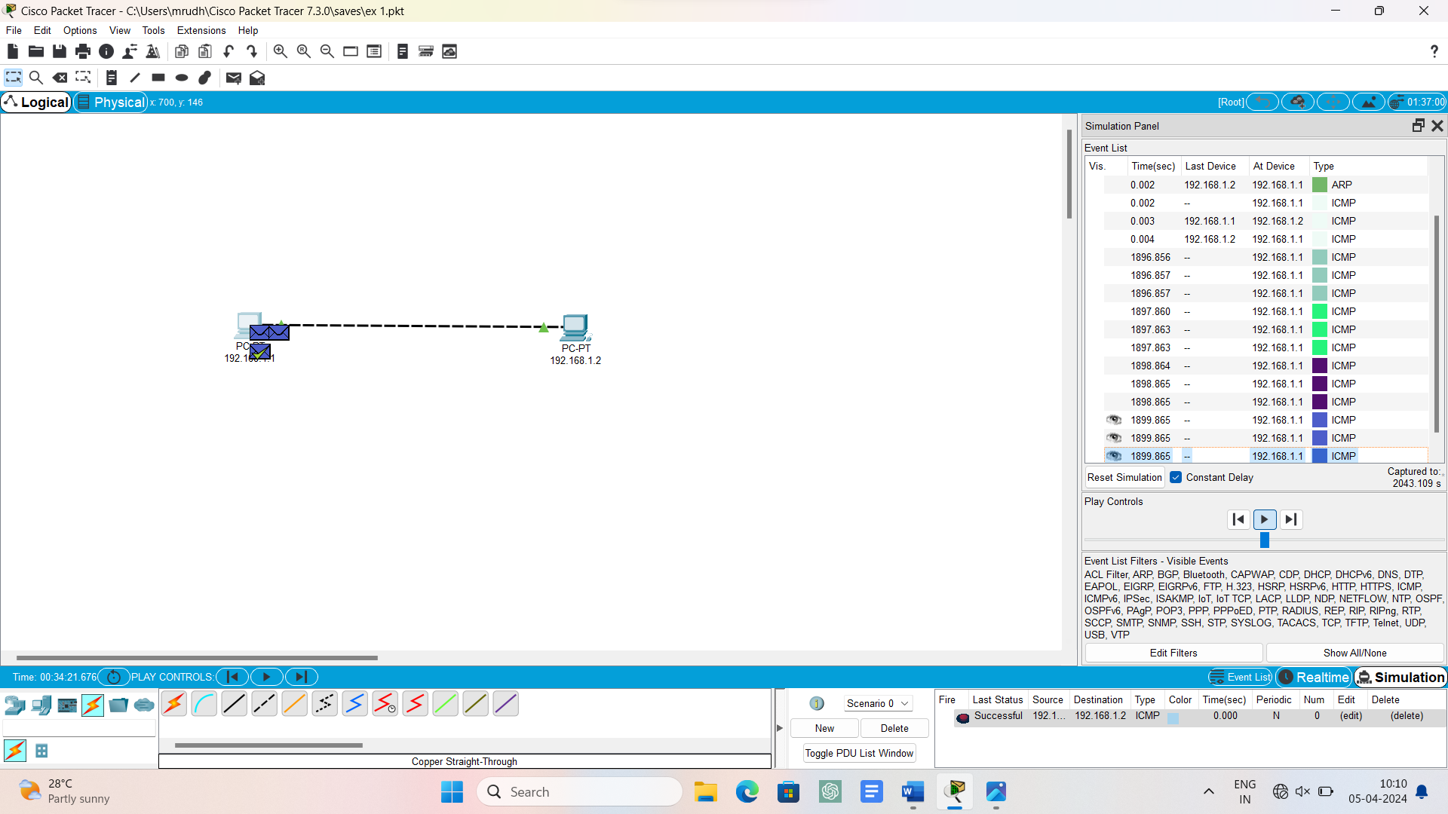

1. **Experiment number2 – star topology**

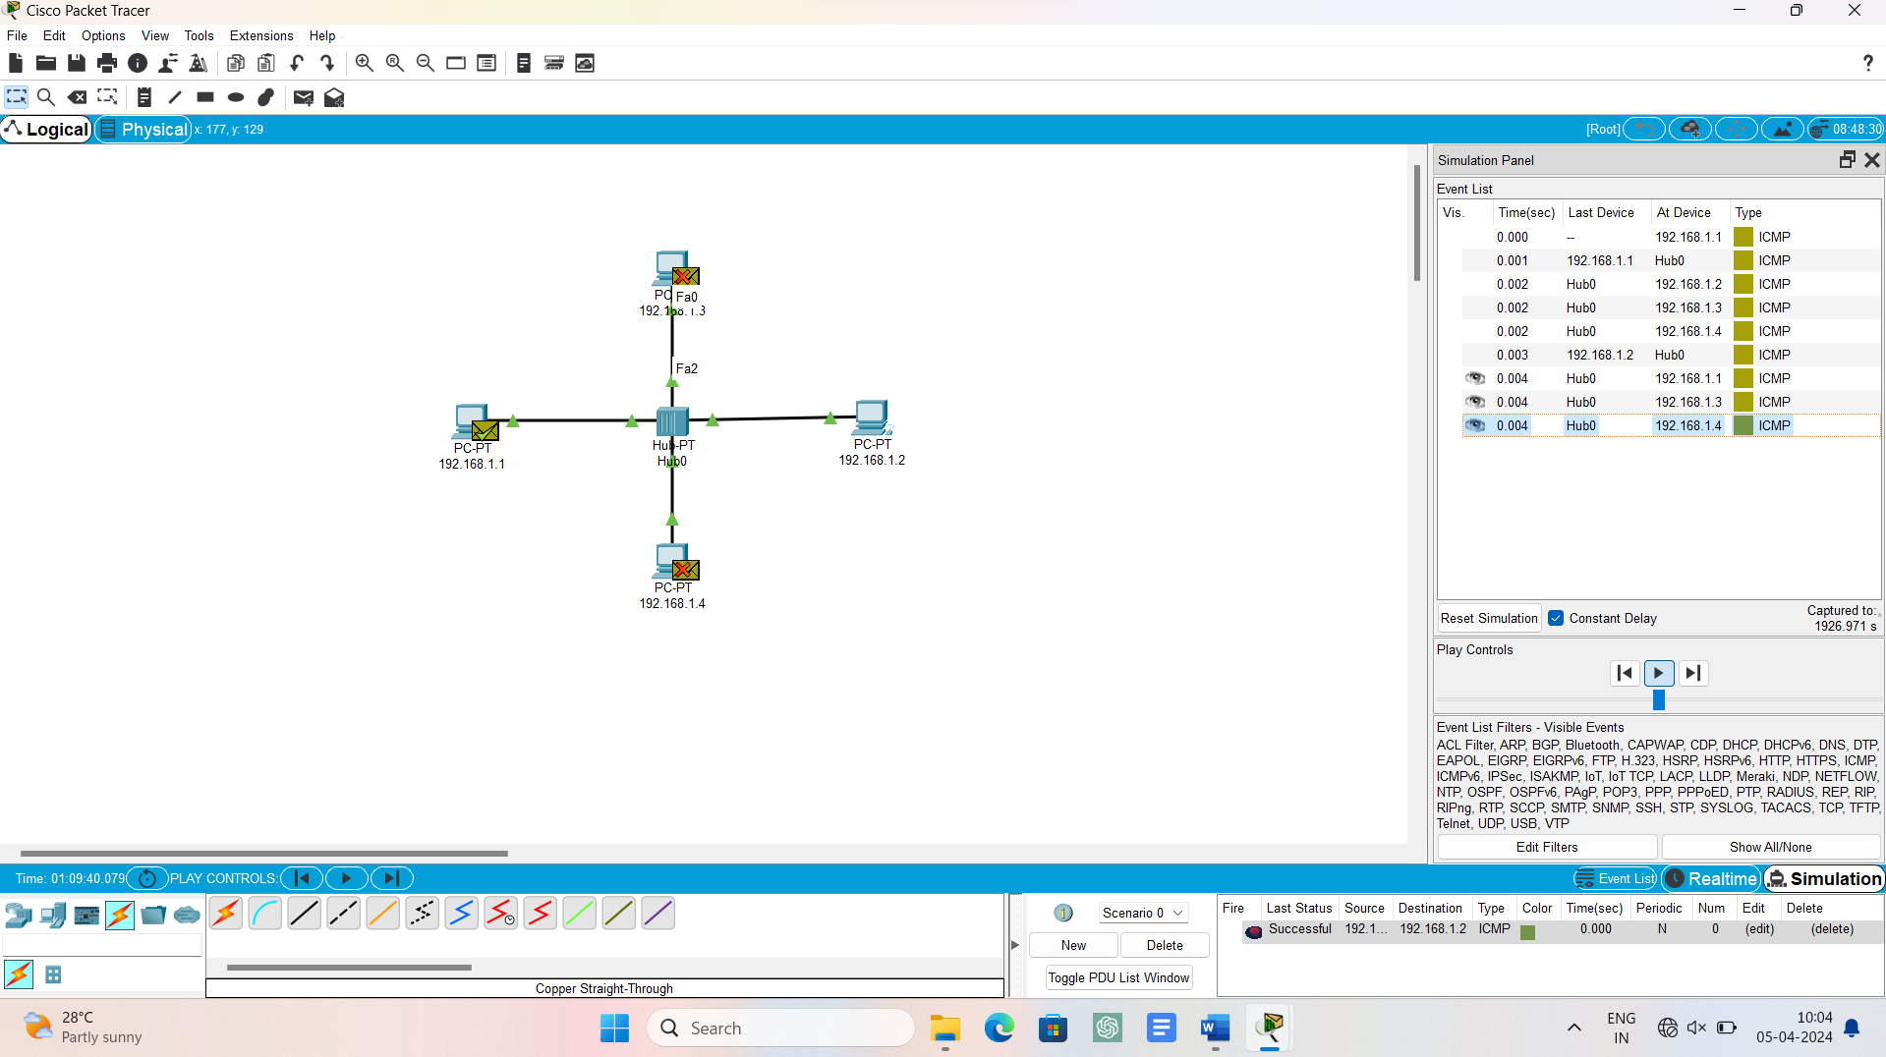

1. **Experiment number3 – bus topology**

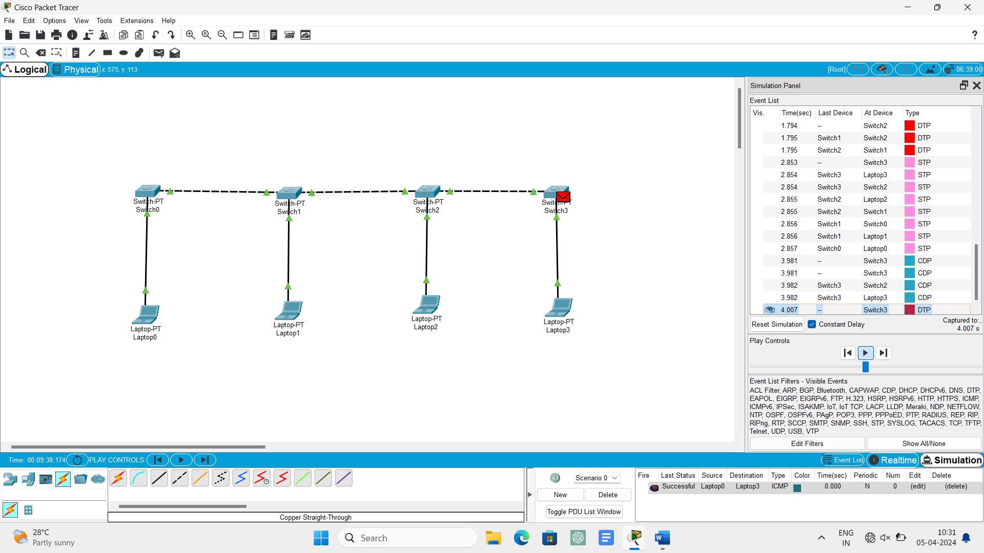

1. **Experiment number4 – ring topology**

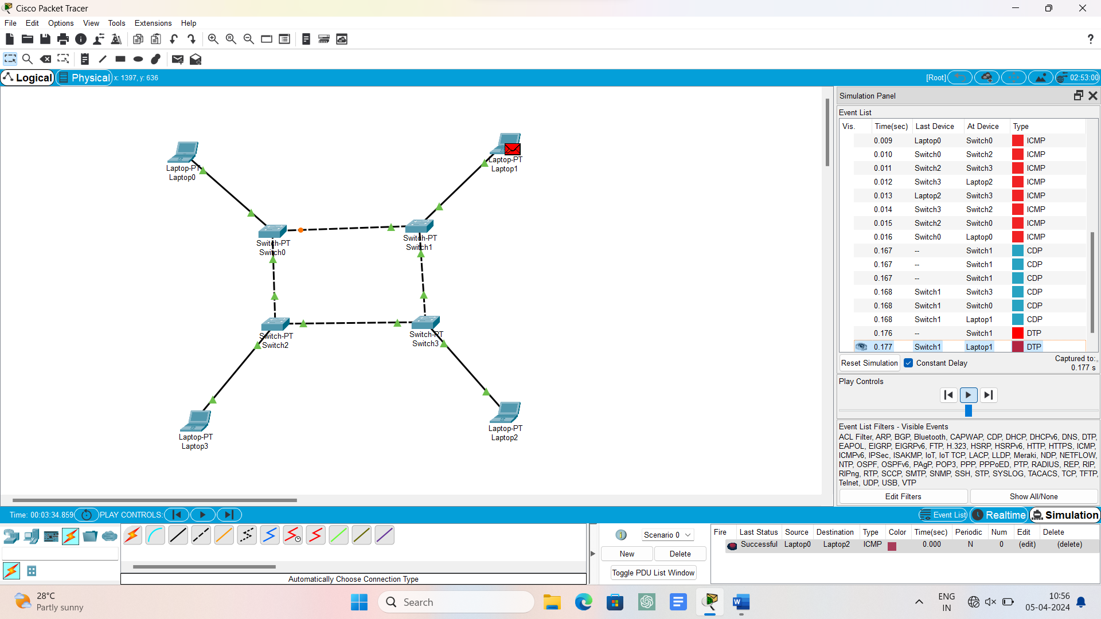

1. **Experiment number5 – mesh topology**

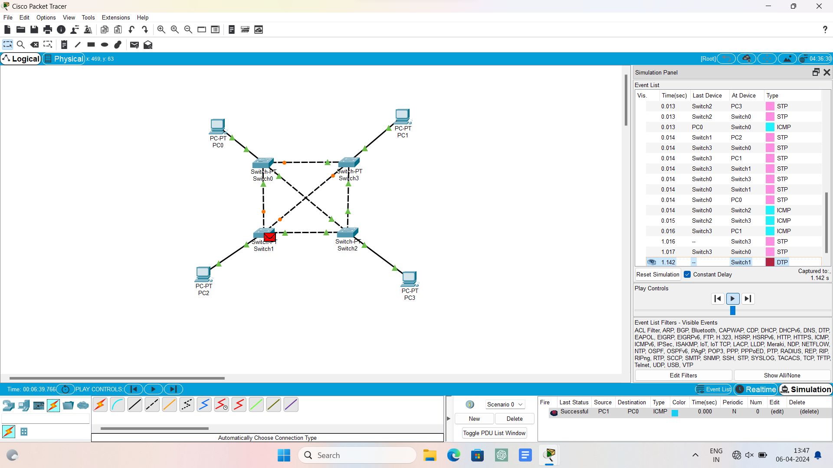

1. **Experiment number6 – tree topology**

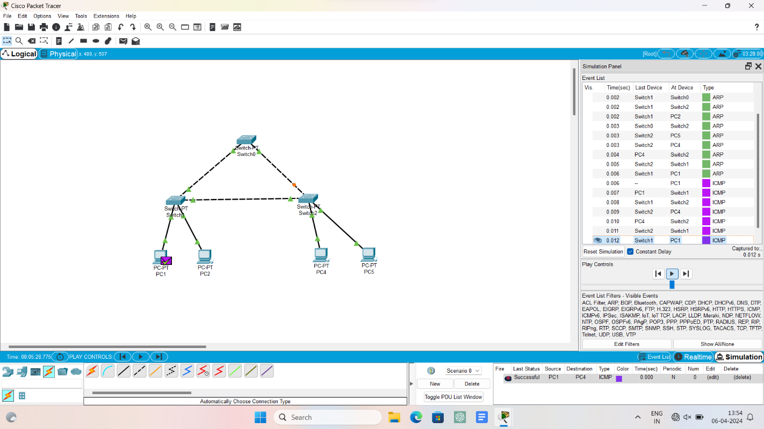

1. **Experiment number7 – hybrid topology**

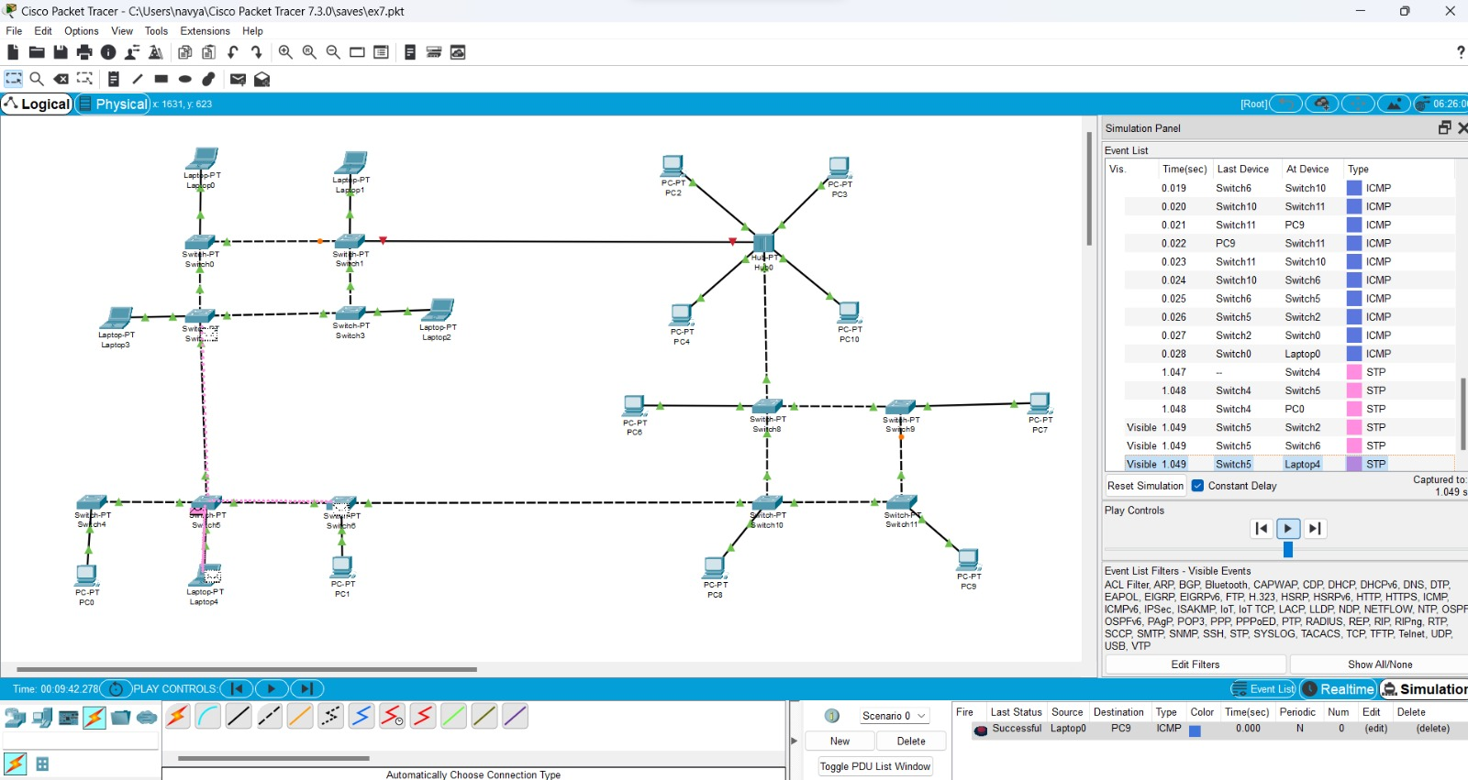

**8.Experiment number8 – ARP**

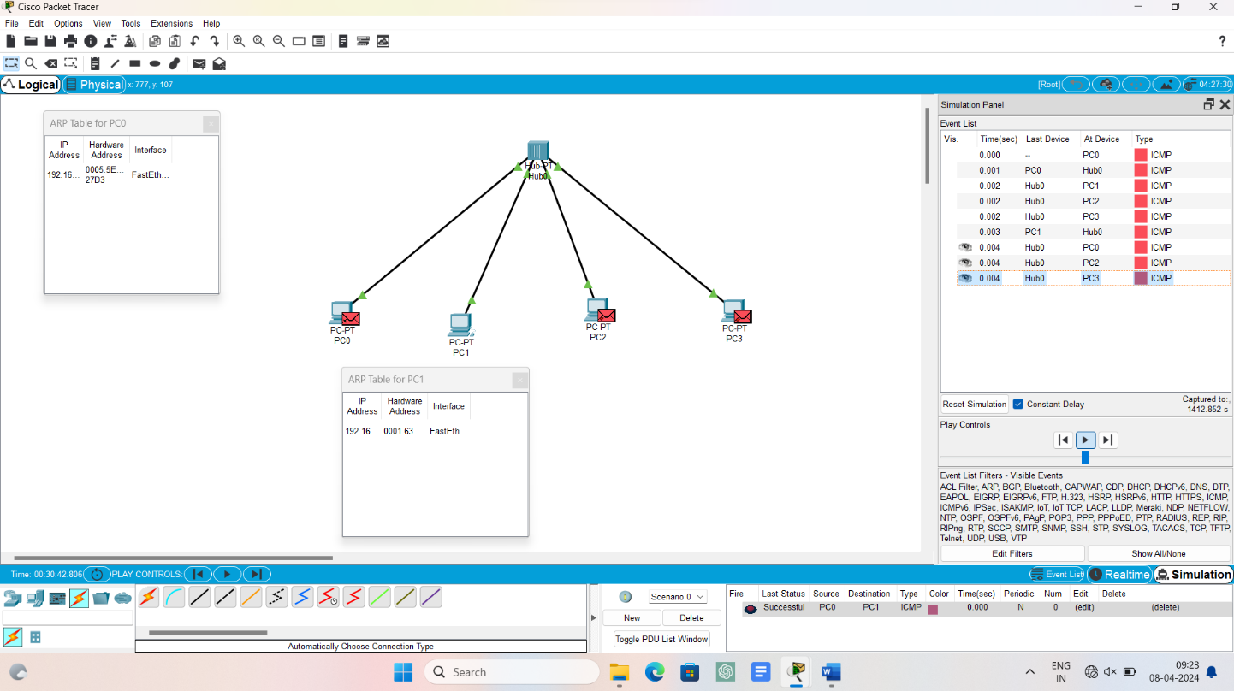

**9.Experiment number9 – LLDP**

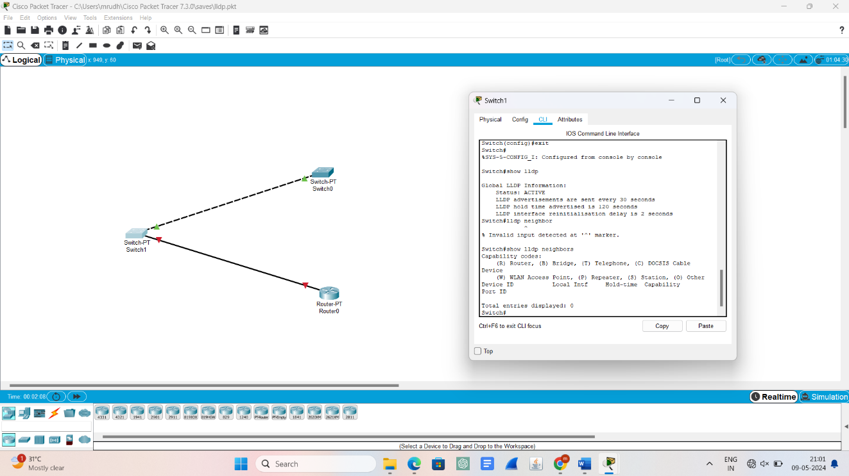

**10.Experiment number10 – CSMA**

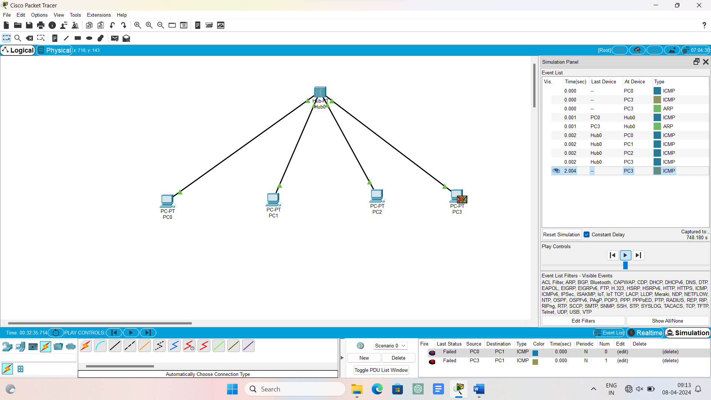

**10.Experiment number10– CSCD**

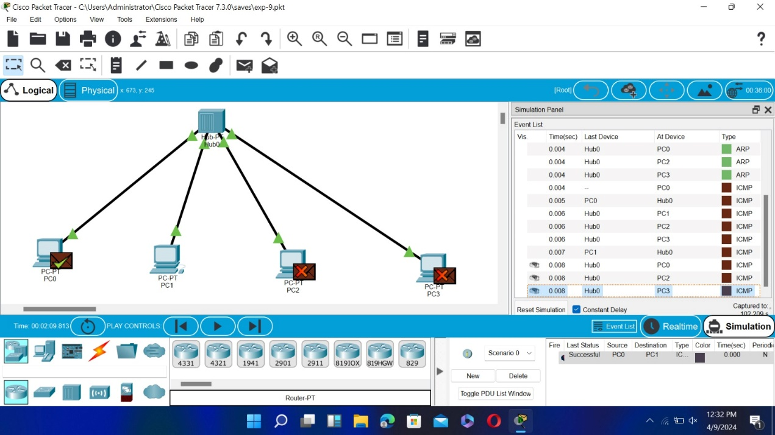

**11.Experiment number11-bit stuffing**

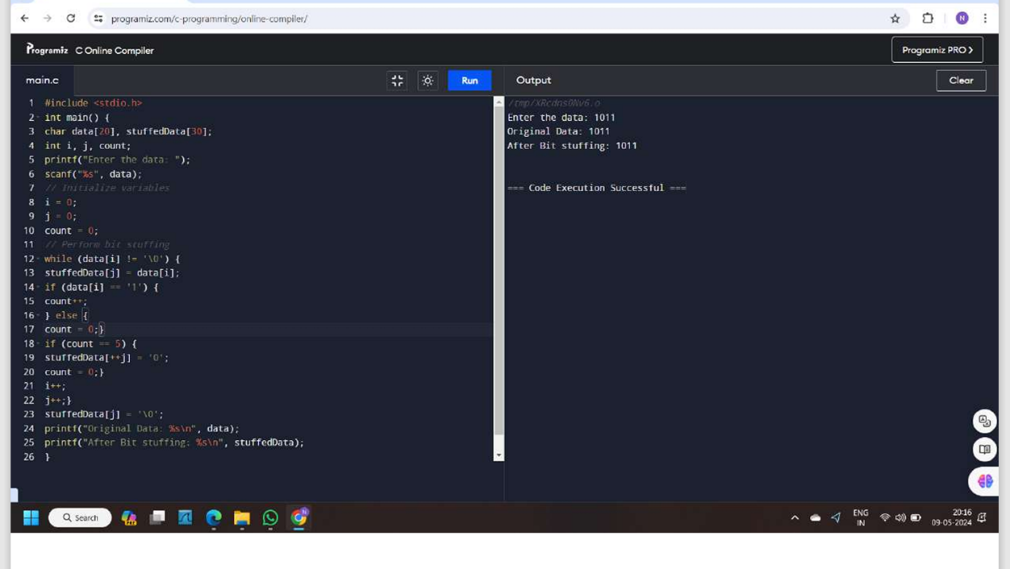

**12.Experiment number12-static routing**

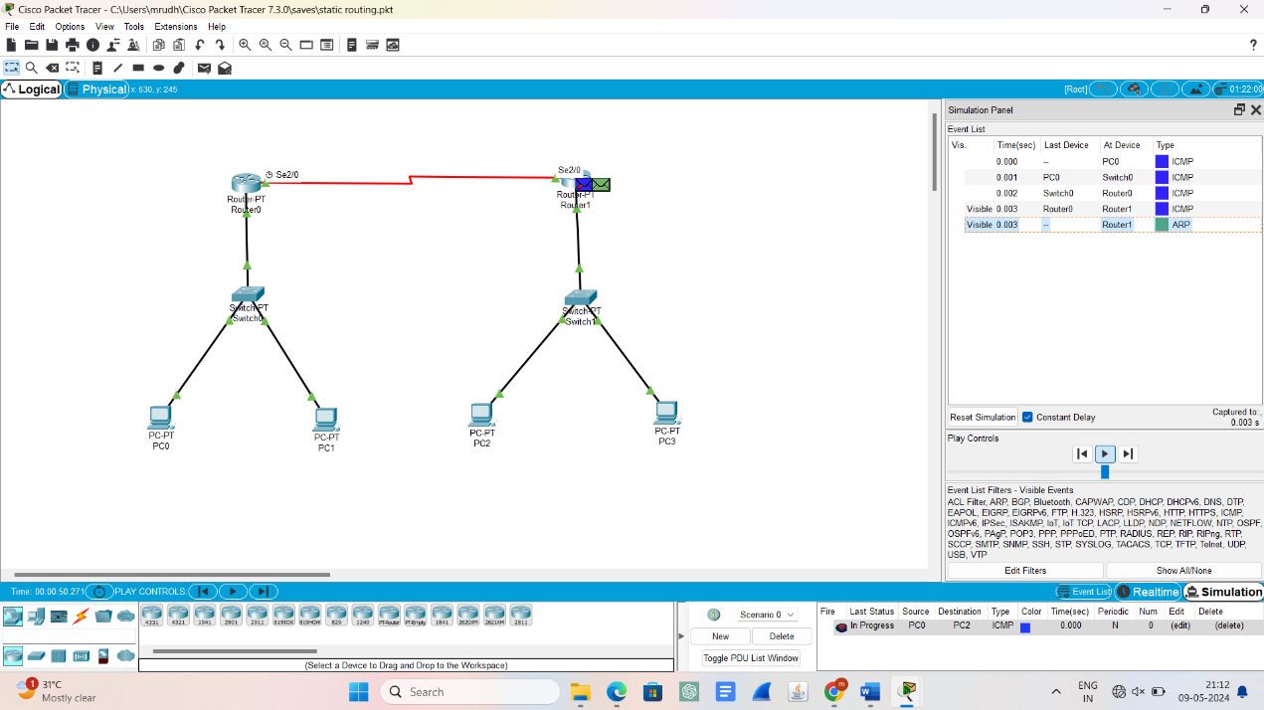

**13.Experiment number13-dynamic routing**

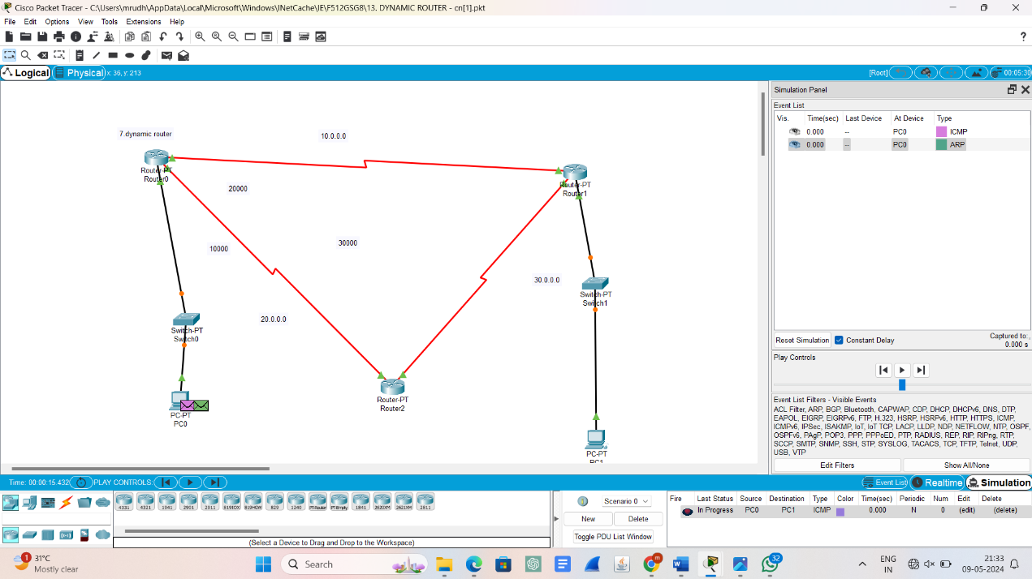

**14.Experiment number14-functionalities of TCP**

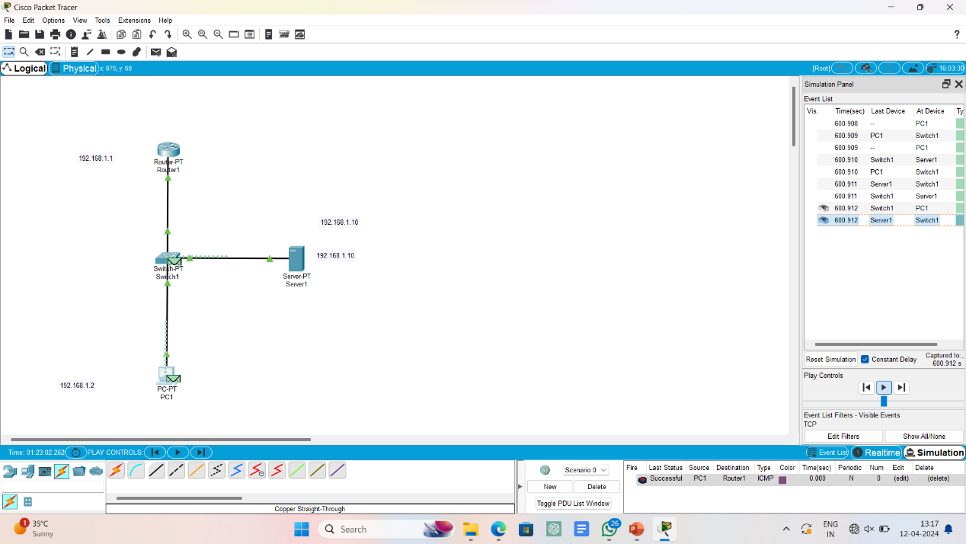

**15.Experiment number15 – functionalities of UDP**



**16.Experiment number16 – subnetting**

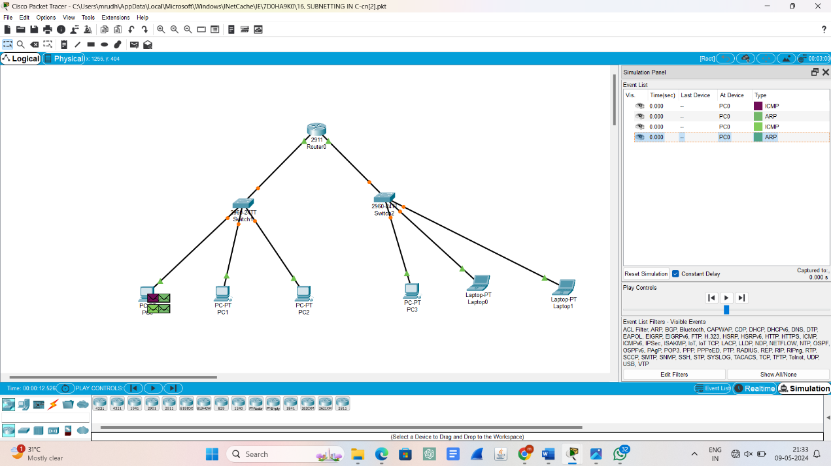

**17.Experiment number17 – TCP socket**

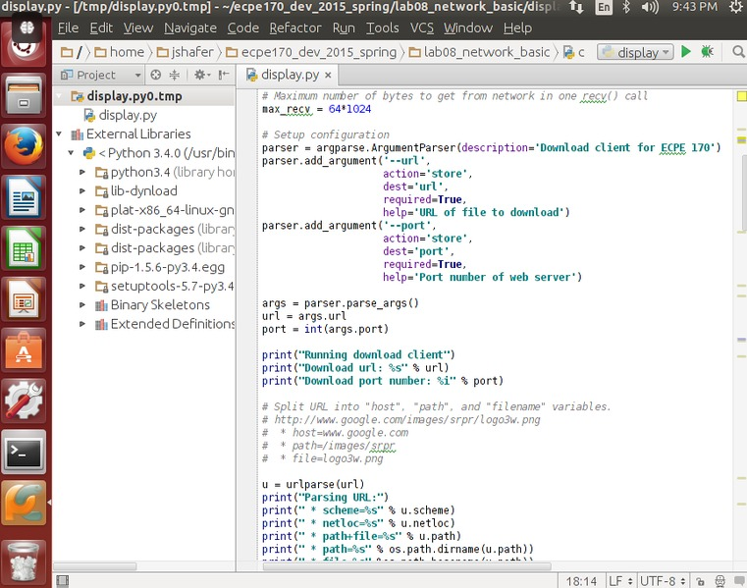

**18.Experiment number18 – UDP socket**

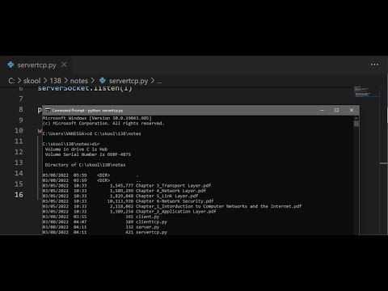

**19. Experiment number19 - Simulating X, Y, Z Company Network Design**

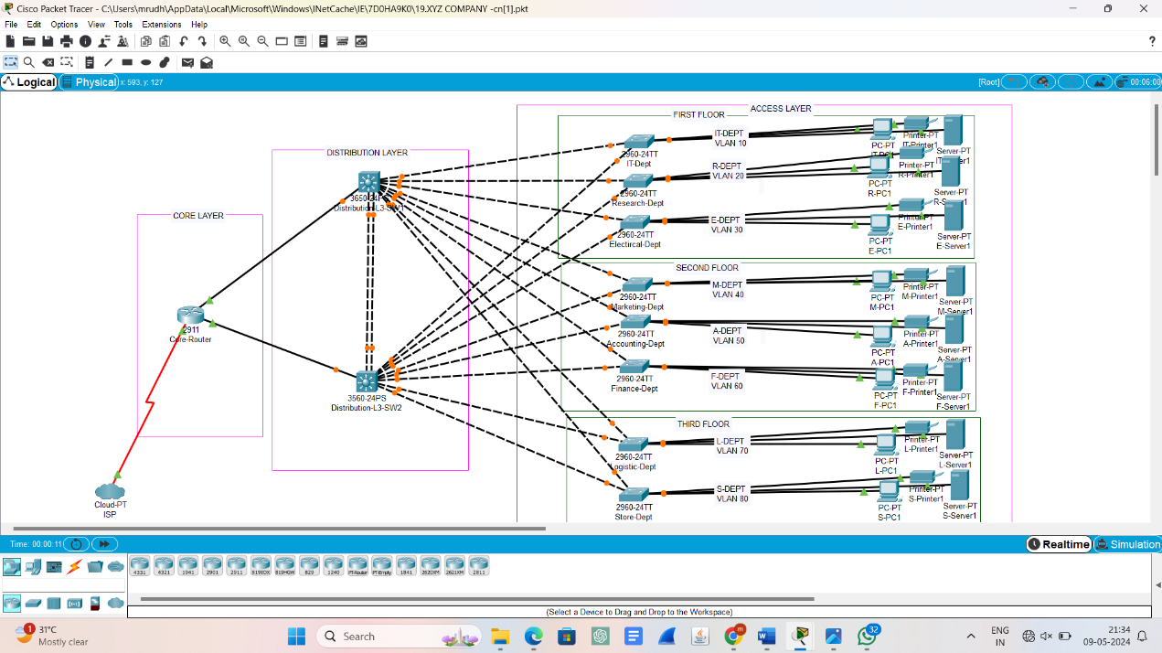

**20. Experiment number 20 – DHCP**

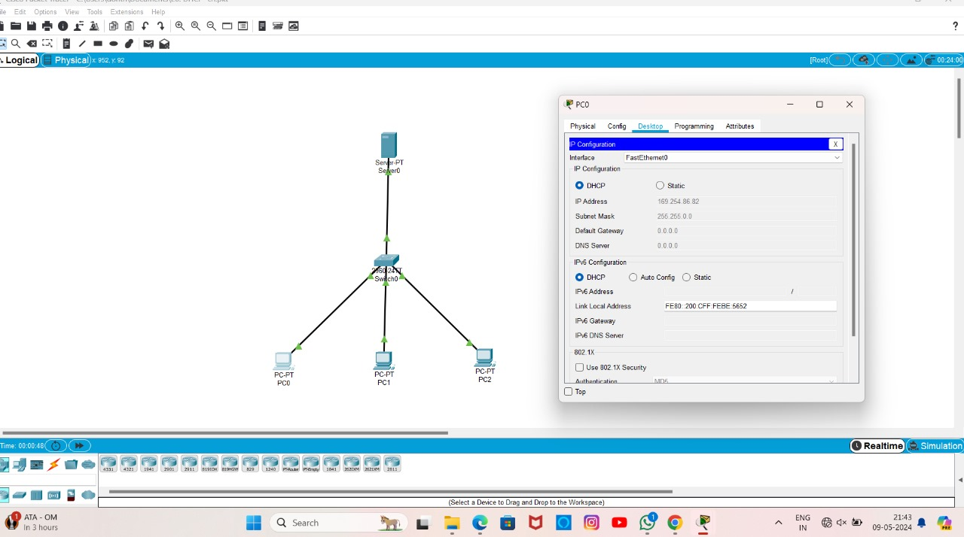

**21.Experiment number21 – firewall topology**

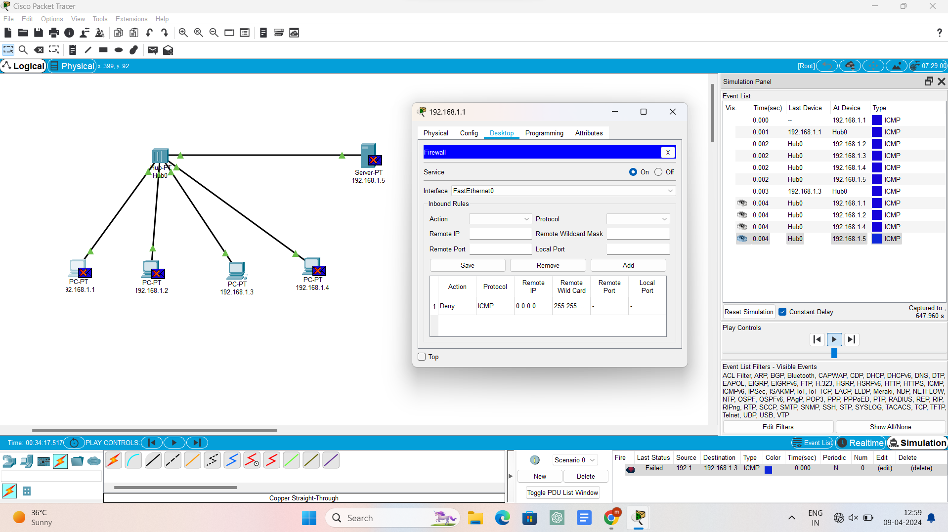

**22.Experiment number22 – message transfer**

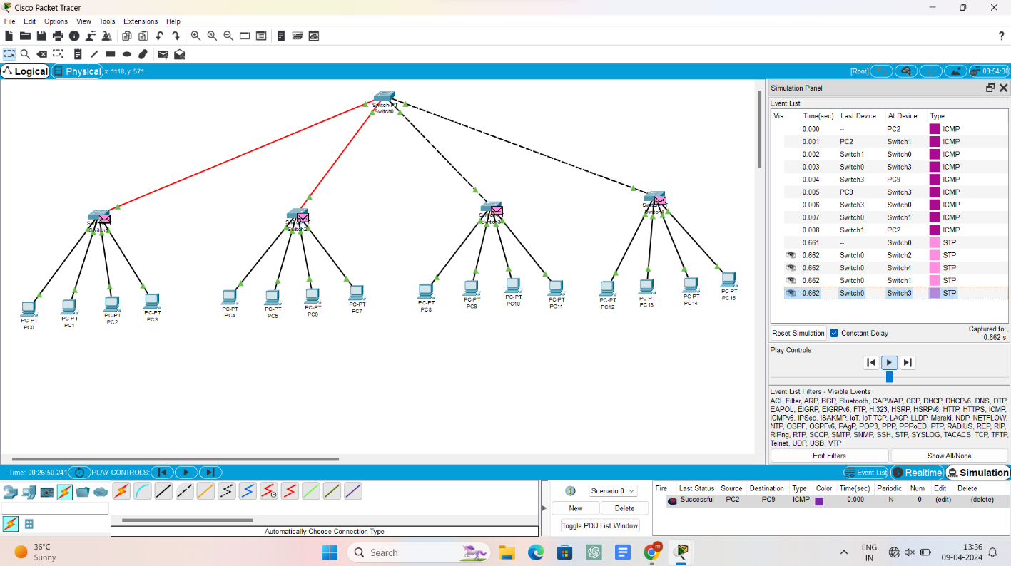

**23. Experiment number 23 – TCP**

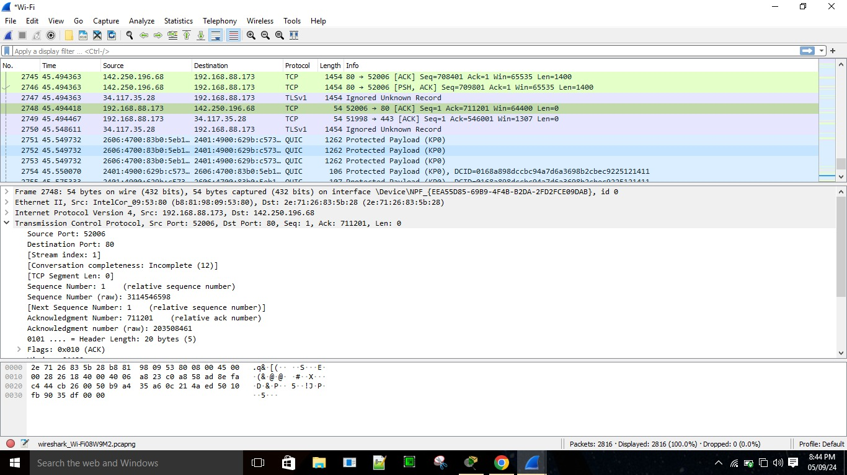

**24.Experiment number 24- SMTP**

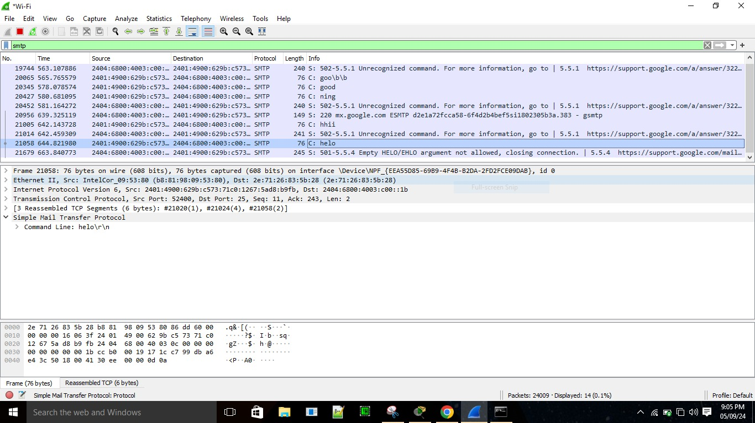

**25.Experiment number 25 – ICMP**

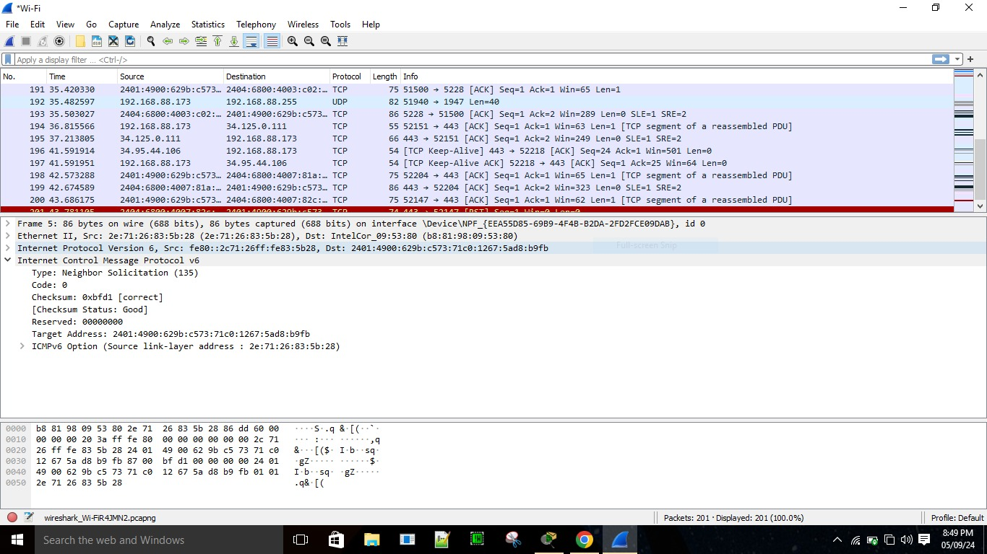

**26.Experiment number 26 – UDP**

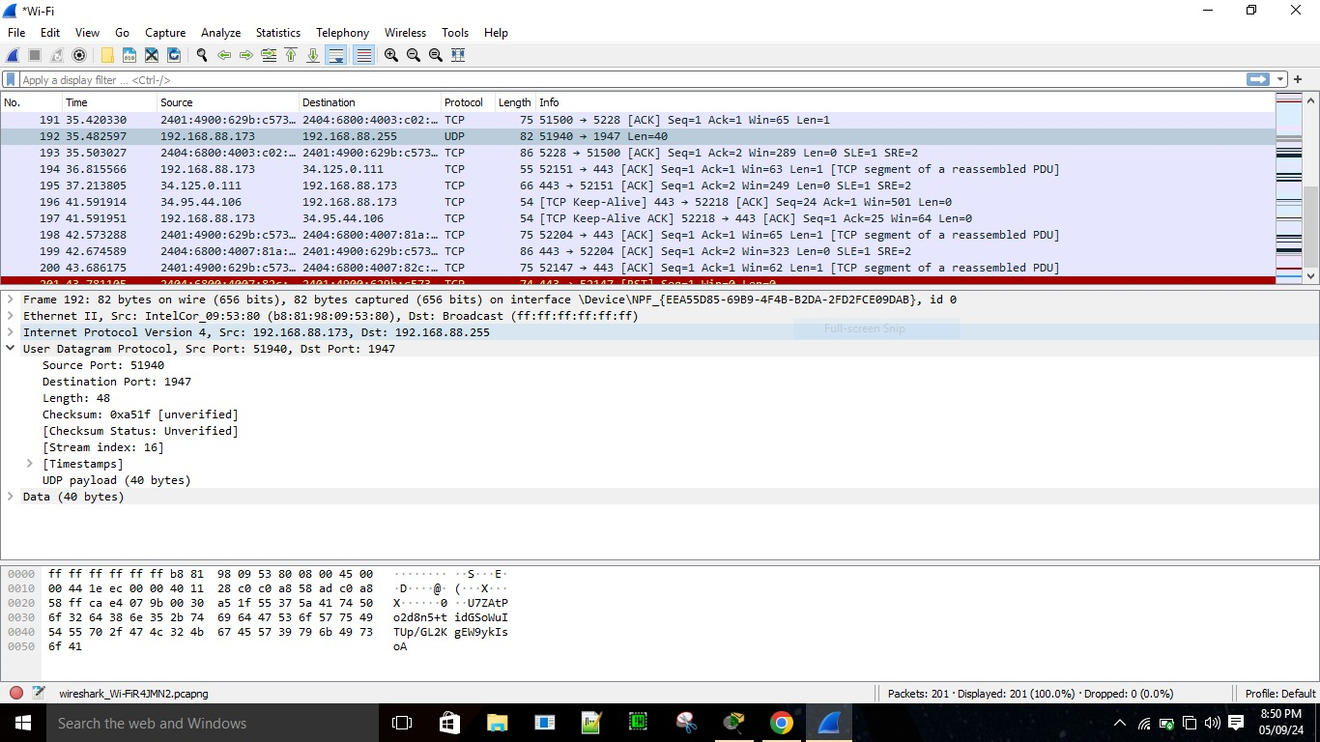

**27.Experiment number 27 – ARP**

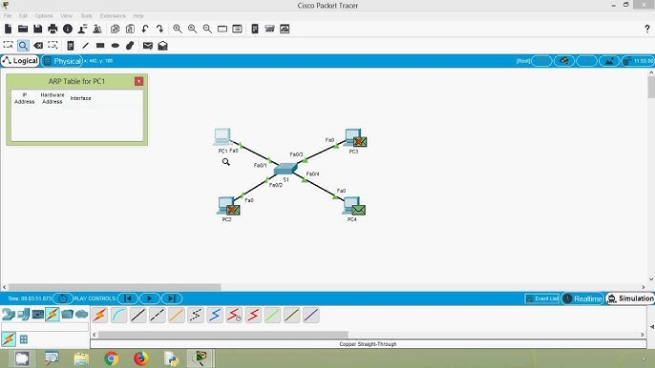

**28.Experiment number 28 – HTTP**

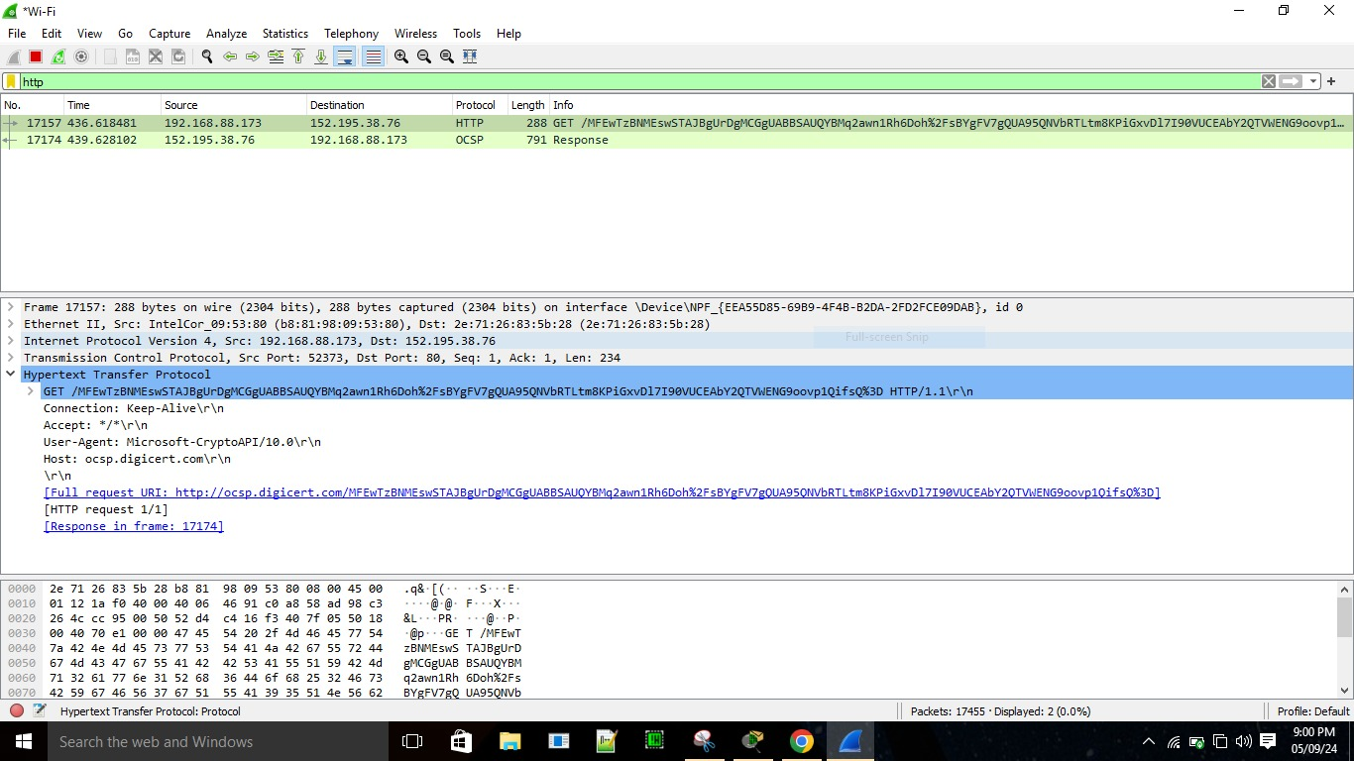

**29.Experiment number 29 – Identify and monitor the IP, network address, Trace the router information, how to take remote system and Check the node connection in network.**

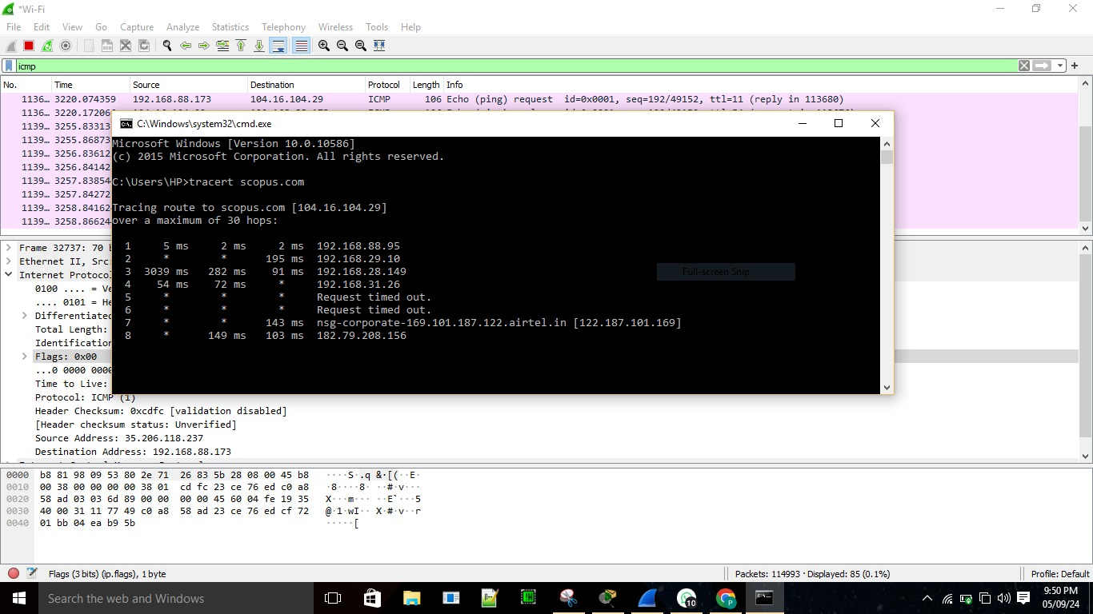

**30.Experiment number 30 - PING operation using ICMP**

